**PyBer Observations and Analysis**

**Pie Chart for Percentage of Total Fares by City Type**

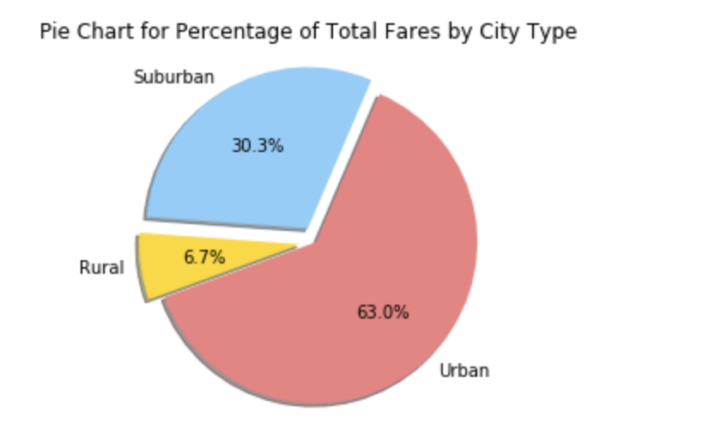

**Pie Chart for Total Rides by City Type**

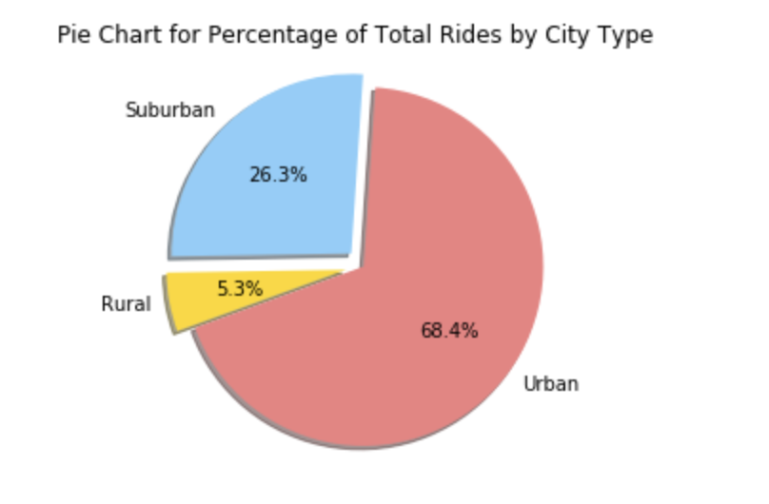

**Pie Chart for Total Drivers by City Type**

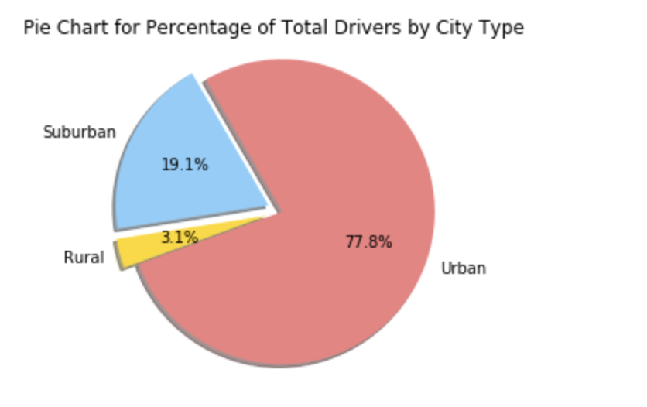

**Observable Trends:**

1. Many observations can be made. Some of them are:
   1. Based on the percentage of fares, rides and drivers, it is very apparent that the most of the business of PyBer is being conducted in the Urban Cities
   2. Urban drivers are almost 78% where as Suburban are less than 20% and Rural are merely 3%
   3. Slightly less than 70% of rides are in Urban Cities, little more than 26% of rides are in Suburban cities. Rural cities have slightly more than roughly 5% (round off) rides.
   4. The fares of Suburban cities generate 30% or revenue, Urban cities generate 63% of revenue and rural cities generate slightly less than 7% revenue.
   5. This could also mean that fares in rural and suburban cities, on average, is slightly ‘more’ than fares of urban cities – either this, or the fact that urban cities have a lot more rides which are ‘shorter distances’ compared to rides in rural and suburban cities. This is because the percentage of rides versus percentage of revenue (compare the first two pie charts with each other) of urban, suburban and rural cities differ by 3-5 points (suburban and urban percentage fares compared to their corresponding percentage rides for example) each.

**Bubble Chart**

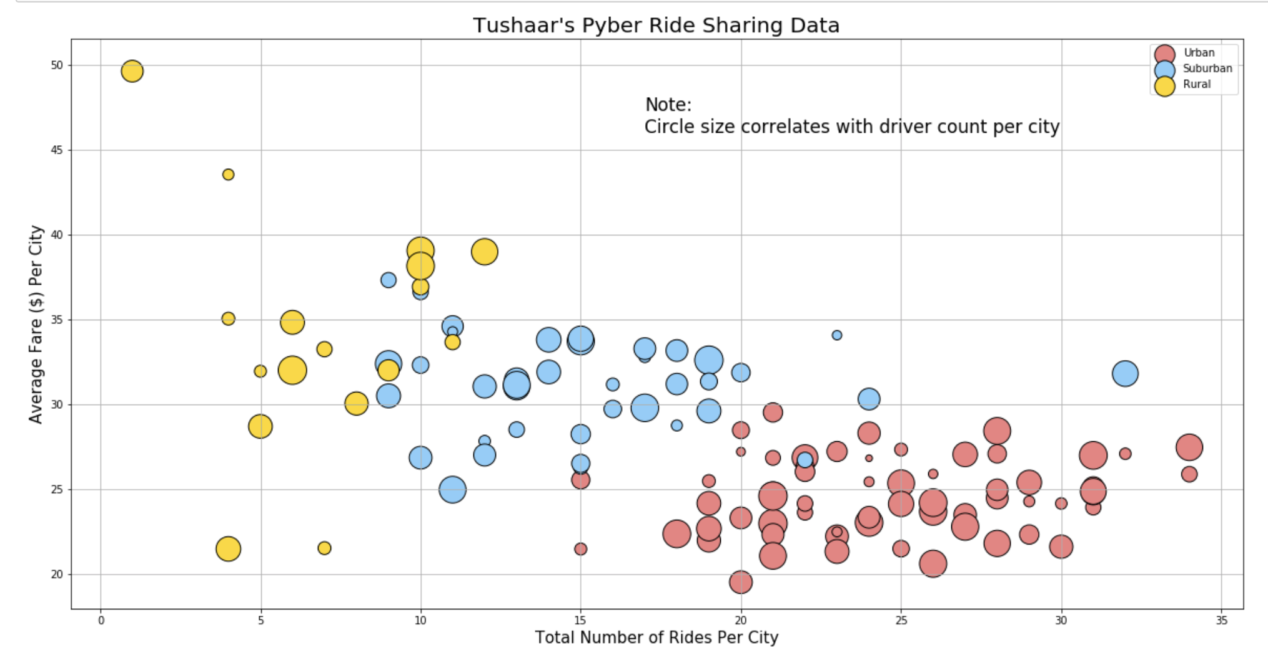

**Observable Trends:**

Many observations can be made here as well, some of these are:

1. Urban cities on an average have 15 to 35 rides where there are many drivers compared to rural and Suburban cities
2. Suburban cities have rides in the magnitude of 7-20, though there are some outliers that go beyond 20, up to even 33 (for one city). Rural cities have rides in the magnitude of 1-13.
3. The average fares in urban cities are generally the lowest – as observed via comparing different pie charts above as well. Suburban cities have higher average fares than urban cities, and our rural cities have the highest average fares – an outlier going as high as almost $50.
4. Very interesting and logical trend because urban cities have more ‘people population’ (more work population, social population etc.) resulting in people asking for more rides, which results in more drivers and lower average fares. The trend decreases as we go to suburban cities and is the lowest as we go to rural cities.